**Question 1**

Design some web page layouts using HTML frameset.

**Source Code**

**frame.html (General format for each frame)**

<!DOCTYPE html>

<html>

<head>

<title>Frame 1</title>

</head>

<body>

<h2>Frame 1</h2>

<p>Contents of Frame 1</p>

</body>

</html>

**layout1.html**

<!DOCTYPE html>

<html>

<head>

<title>Frameset Layout 1</title>

</head>

<frameset cols="34%,33%,33%">

<frameset rows="50%,50%">

<frame src="frames/frame1.html" name="frame1">

<frame src="frames/frame2.html" name="frame2">

</frameset>

<frame src="frames/frame3.html" name="frame3">

<frame src="frames/frame4.html" name="frame4">

</frameset>

</html>

**layout2.html**

<!DOCTYPE html>

<html>

<head>

<title>Frameset Layout 2</title>

</head>

<frameset rows="30%,70%">

<frame src="frames/frame1.html" name="frame1">

<frameset cols="30%,40%,30%">

<frame src="frames/frame2.html" name="frame2">

<frame src="frames/frame1.html" name="frame1">

<frame src="frames/frame4.html" name="frame4">

</frameset>

</frameset>

</html>

**layout3.html**

<!DOCTYPE html>

<html>

<head>

<title>Frameset Layout 3</title>

</head>

<frameset rows="30%,30%,40%">

<frame src="frames/frame1.html" name="frame1">

<frameset cols="33%,34%,33%">

<frame src="frames/frame2.html" name="frame2">

<frame src="frames/frame3.html" name="frame3">

<frame src="frames/frame4.html" name="frame4">

</frameset>

<frame src="frames/frame5.html" name="frame5">

</frameset>

</html>

**Output**

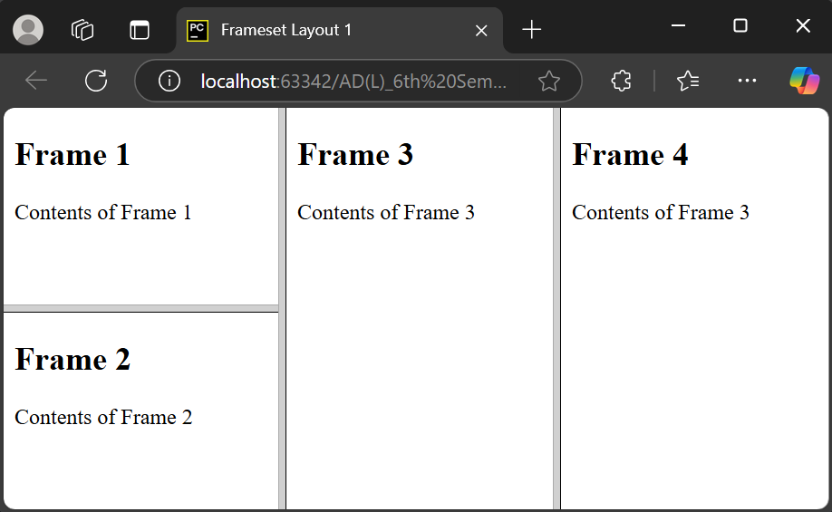*Layout 1*

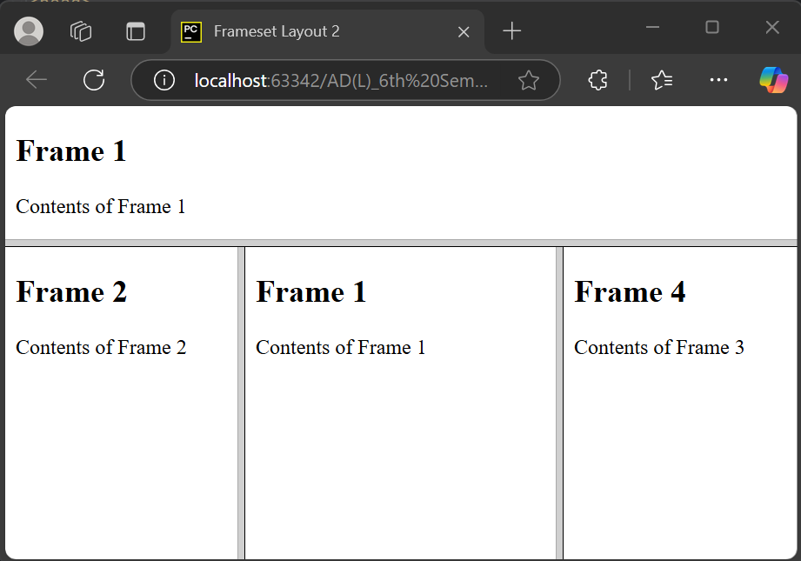*Layout 2*

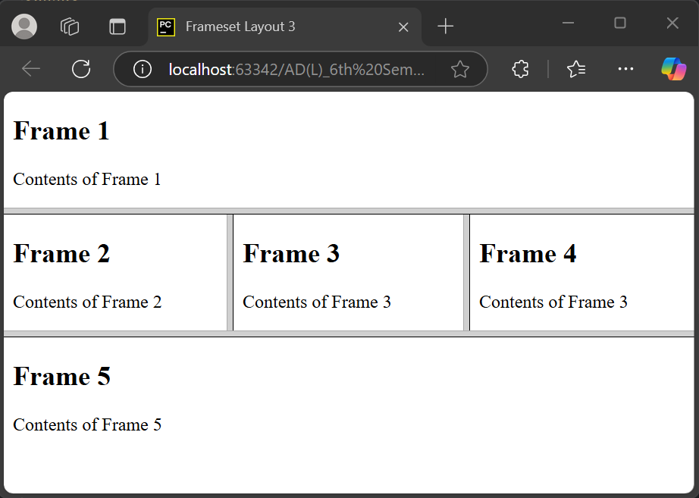*Layout 3*

**Question 2**

Question 2: Do the following using HTML/CSS. Step 1: Create a .html document with the standard HTML-structure (<html>, <head>, <body> etc.). Set up a basic structure following HTML5 semantics that includes a header-element to contain a menu with links to relevant pages and a picture of you. Further, the page should include a section that present projects that you have been part of in a list, and/or similar sections with work experience, and courses and educational institutions attended. One section presenting one of the examples above is sufficient.

Step 2: Create a .css file and link to it in your HTML-document. Add styles to the different components of the page.

**Source Code**

**index.html**

<!DOCTYPE html>

<html lang="en">

<head>

<meta charset="UTF-8">

<meta name="viewport" content="width=device-width, initial-scale=1.0">

<title>Portfolio</title>

<link rel="stylesheet" href="styles.css">

</head>

<body>

<header>

<h1>Magnus Li – Student at UiO</h1>

<img src="pfp.png" alt="Profile Picture">

<nav>

<a href="#">Github</a> –

<a href="#">Instagram</a> –

<a href="#">LinkedIn</a>

</nav>

</header>

<section class="projects">

<h2>Projects</h2>

<div class="projects-container">

<div class="project">

<h3>Something (2017)</h3>

<p>Simple web project that allow….</p>

</div>

<div class="project">

<h3>Something (2017)</h3>

<p>Website written in js, php, …..</p>

</div>

<div class="project">

<h3>Something (2015)</h3>

<p>Blablabla….</p>

</div>

<div class="project">

<h3>DHIS2-LMIS (2015)</h3>

<p>Commodity ordering system for DHIS1 blablabla</p>

</div>

<div class="project">

<h3>Something (2011)</h3>

<p>Blablabla….</p>

</div>

<div class="project">

<h3>Something (2011)</h3>

<p>Blablabla….</p>

</div>

</div>

</section>

<section class="work-experience">

<h2>Work experience</h2>

</section>

</body>

</html>

**styles.css**

body {

font-family: Arial, sans-serif;

text-align: center;

margin: 0;

padding: 0;

}

header {

border: 2px solid black;

padding: 20px;

margin: 10px;

}

header img {

width: 100px;

height: 100px;

border-radius: 0%;

margin: 10px;

}

nav a {

text-decoration: none;

color: black;

font-weight: bold;

margin: 0 10px;

}

.projects {

border: 2px solid black;

margin: 10px;

padding: 20px;

}

.projects-container {

display: grid;

grid-template-columns: repeat(3, 1fr);

gap: 10px;

justify-content: center;

}

.project {

border: 2px solid black;

padding: 20px;

}

.work-experience {

border: 2px solid black;

padding: 20px;

margin: 10px;

}

**Output**

